**DAILY ONLINE ACTIVITIES SUMMARY**

|  |  |  |  |  |  |  |  |
| --- | --- | --- | --- | --- | --- | --- | --- |
| **Date:** | **26/06/2020** | | | | **Name:** | **Churashma** | |
| **Sem & Sec** | **4th SEM 'A' Section** | | | | **USN:** | **4AL18CS019** | |
| **Online Test Summary** | | | | | | | |
| **Subject** | | **No test** | | | | | |
| **Max. Marks** | | **-** | | **Score** | | **-** | |
| **Certification Course Summary** | | | | | | | |
| **Course** | **Introduction to R** | | | | | | |
| **Certificate Provider** | | | **greatlearning academy** | **Duration** | | | **3.5 hours** |
| **Coding Challenges** | | | | | | | |
| **Problem statement 1: Given start and end of a range, write a Python program to print all negative numbers in given range.** | | | | | | | |
| **Status: completed** | | | | | | | |
| **Uploaded the report in Github** | | | | **yes** | | | |
| **If yes Repository name** | | | | **https://github.com/Churashma/Lockdown-coding** | | | |
| **Uploaded the report in slack** | | | | **yes** | | | |

ONLINE TEST DETAILS: No test.

CERTIFICATION COURSE DETAILS: Today I studied about Plots_Combinations. A 3-D array, matrix, list of matrices, or data frame of MCMC draws. The MCMC-overview page provides details on how to specify each these allowed inputs.A character vector with at least two elements. Each element of combo corresponds to a column in the resulting graphic and should be the name of one of the available MCMC functions.

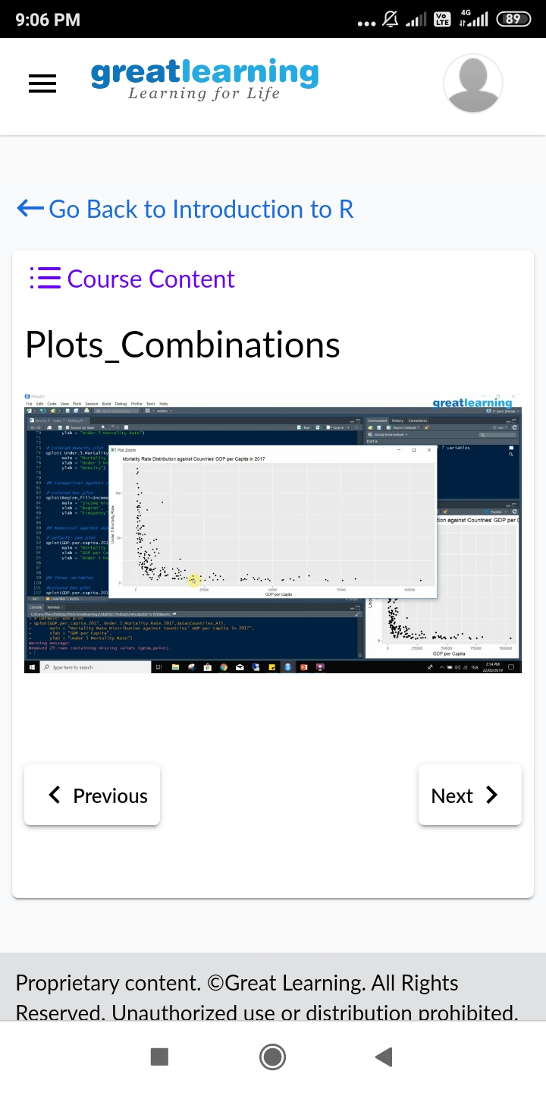

**CODING CHALLENGES DETAILS**:

Problem statement 1: Given start and end of a range, write a Python program to print all negative numbers in given range.

